MS/MPhil Proposal Form for BASR

Presentation Date: | ……………. | Program (Dept): MS (Mathematics & Scientific Computing
Name of Student: Muhammad Umair Arif |  | Registration No. (Complete): 20242-35517
Date of Admission: | 01-01-2024 | Course Completed (semester): | ……………………
Name of Supervisor: | Dr. Faiza Rubab Co-Supervisor (If any): Dr. Urooj Yousuf
Title of Thesis (Capitalize Each Word): | Mathematical design and analysis of a Parametrized Exponential Tanh Activation (PETA) function for improved neural network optimization
Note: A word count of 1500 (Maximum) with a font size of 11 (Times New Roman).
Only the relevant references should be added.
 |  | Yes | No
a) | Correspond to the community needs at the regional and local levels
b) | National Research Agenda
c) | Signifies emerging areas of research that coincide with SDGs # | ________________________

- Introduction and Literature Review Summary
In early neural networks common sigmoid and hyperbolic tangent functions can result in very small gradients in deep networks because of their saturation properties. The sigmoid function remains viable because of its smoothness and bounded output, but its vanishing gradient stressed a way to develop modified sigmoid-based activation functions that retain its desirable properties while improving gradient propagation and convergence. [1] highlighted that sigmoid can cause vanishing gradient that makes more difficult for deep learning model to be trained. Rectified Linear Units (ReLU) were shown to be useful in [2]. [2]showed that ReLU activation enhances the representation learning of Restricted Boltzmann Machines in comparison to traditional binary units. Their work showed that ReLU is non-saturating and simple in computing due to its simplicity and good gradient behavior in positive region. But its zero output and zero derivative for negative inputs led to the development of modified function or other alternatives.In [3] found out that the selection of an activation function has substantial impact on operation of deep neural network. However, the study paid attention to only speech recognition, leaving area for probing modified functions for improving convergence, training efficiency, and stability., [4] proposed Parametric ReLU (PReLU), an alteration in ReLU that made learning available for negative inputs. Their PReLU-based model worked very well on ImageNet, The study further stressed the possibility of modifying ReLU to improve deep neural network learning. [5] proposed Exponential Linear Units (ELUs) to improve the training of deep neural networks. The study showed that ELUs could peform better thanReLU-based activations in many tasks. Future research can explore adaptive ELU variants to further to imrpove the training of model. Later, [6] proposed Scaled Exponential Linear Units (SELUs) to create neural networks that adjust its own stability without external tuning. Theymaintain approximately zero mean and unit variance across the architecture improving the training performance.

[7] Proposed GELU, a smooth activation function that improves gradient flow by weighting inputs according to their magnitude. It shows stellar outcomes in various tasks of deep learning. [8] proposed SILU and it showed better performance in reinforcement learnin. [9] introduced Swish that also outperformed RELU in several tasks of deep learning. [10] proposed Mish to accelerate the flow of gradient. A number of experiments showed better performance of Mish compared with RELU and other functions.More recently, researchers have investigated parameterized and adaptive activation functions, including RSigELU, APTx, and RoSwish, to improve gradient flow, convergence, flexibility, or computational efficiency. [11] Their work supports further investigation of improved sigmoid-based activations. [12] The study emphasize ons the need for activation functions that improve gradient propagation and training efficiency.

The growing number of activation functions has motivated systematic reviews and comparative studies. [13] and [14] exhibited the rapid transformation and diversity of activation functions, while [15] investigated their approximation capabilities. [16] studied TeLU (Tanh Exponential Linear Unit) for deep neural networks to improve the stability. Overall, existing research indicates that activation functions should be evaluated not only by prediction accuracy but also by gradient behavior, convergence, computational efficiency, and stability. In light of this literature, the present study investigates a parameterized activation-function family and examines how its parameter affects mathematical properties, gradient behavior, and deep-learning performance.

- Problem Statement
As activation functions strongly influence gradient propagation, convergence, and the Activation functions strongly influence gradient propagation, convergence, and the learning performance of deep neural networks. This research investigates the parameterized activation function
$$f\left(x\right)=xtanh(a^{x})$$
where (a) is a parameter. For (a=e), the function corresponds to TeLU. The main objective is to investigate how variation in the parameter (a) affects the mathematical properties and learning behavior of the activation function.
The study will analyze the effect of (a) on the function shape, derivative and gradient behavior, convergence, training efficiency, and predictive performance through mathematical analysis and experimental evaluation in deep neural networks.

- Study Objectives/ Questions

  - Study Objectives
Th study objectives of this research study are:
      - To investigate the parameterized activation function
$$f\left(x\right)=xtanh\left(a^{x}\right)$$
      - To analyze its mathematical properties, including continuity, differentiability, range, asymptotic behavior, and derivative characteristics, and to examine how variation in the parameter (a) affects these properties and gradient behavior.
      - To investigate the effect of variation in (a) on the training behavior of deep neural networks, including gradient flow, convergence, training time, loss, and predictive accuracy.
      - To compare the performance of the parameterized activation function with established activation functions, including ReLU, PReLU, ELU, GELU, SiLU/Swish, and Mish, and determine the relationship between the parameter (a), the mathematical behavior of the function, and neural-network performance..

  - Research Questions
This study aims to investigate the effect of the parameter (a) on the mathematical and learning behavior of the activation function
$$f\left(x\right)=xtanh\left(a^{x}\right)$$
Therefore, the study will attempt to answer the following research questions:
- How does variation in the parameter (a) affect the mathematical properties and shape of the activation function.
- How does variation in (a) influence the derivative and gradient behavior of the activation function during neural-network training?
- How does the choice of (a) affect the convergence behavior and training efficiency of deep neural networks?
- How does the performance of the activation function vary with different parameter settings in terms of loss, predictive accuracy, training time, and generalization?
- How does the parameterized activation function compare with established activation functions, including TeLU, ReLU, PReLU, ELU, GELU, SiLU/Swish, and Mish, in terms of gradient behavior, convergence, training efficiency, and predictive performance?

- Research Model/Hypothesis

  - Research Model
The proposed research model is based on the assumption that the selection of an activation function determines the learning behavior of the deep neural network.
The study will examine the relationship:

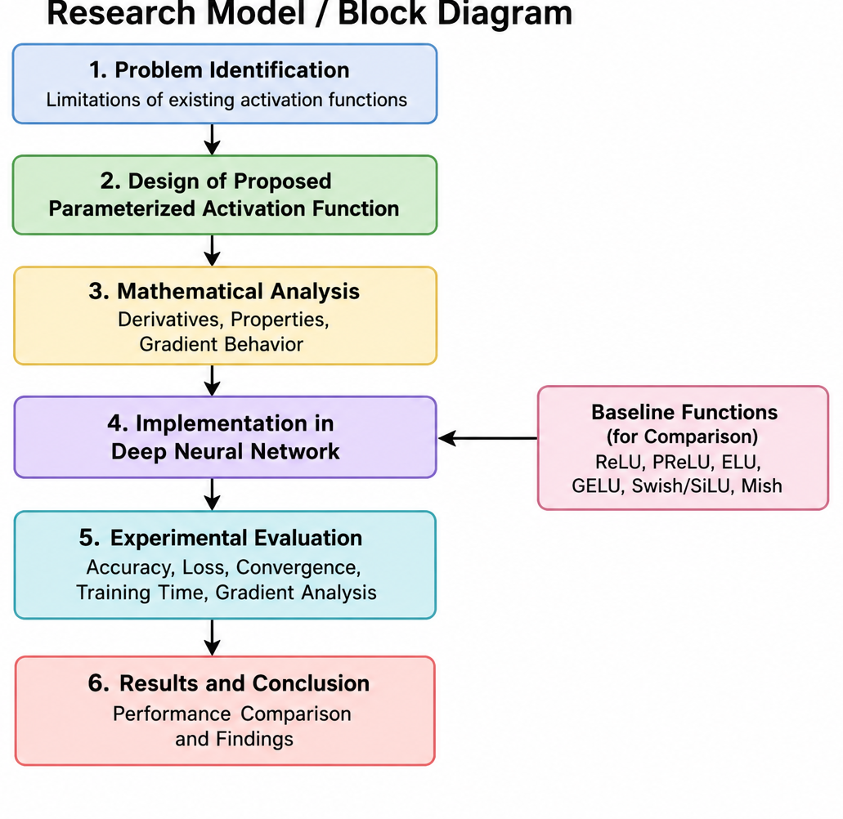

  - Variables
Independent Variable:
- Parameter a of the proposed parameterized activation function.
Dependent Variables:
- Gradient magnitude/attenuation
- Convergence speed
- Training time
- Training loss
- Model accuracy
Control Variables:
- Network architecture
- Dataset
- Optimizer
- Learning rate
- Batch size
- Number of epochs
Comparison/Baseline Functions:
- ReLU, PReLU, ELU, GELU, SiLU/Swish, Mish and TeLU will be used for performance comparison.
  - Research Hypothesis

H₀ (Null Hypothesis): There is no significant difference in the measured performance of the proposed PETA and the baseline activation functions (TeLU, ReLU, GELU, and Mish).
H₁ (Alternative Hypothesis): The proposed PETA shows a significant improvement in at least one of the measured performance variables compared with the baseline activation functions (TeLU, ReLU, GELU, and Mish).

- Research Methodology
  - Data Collection
The Datasets used in this research study are:
- FashionMNIST Dataset on MLP architecture
- CIFAR-10 Dataset with DenseNET CNN
- ImageNet Dataset with Resnet 18 architecture
- Text8 Dataset with Dynamic Pooling Transformer
- Pen TreeBank Dataset with RNN architecture
- CIFAR-100 with SqueezeNext
- Tiny Image Dataset with Resnet 34

A multiple number of training sessions will run on the mentioned dataset with their architectures using different activation functions combined with different optimization techniques. Collecting numerical gradient values, training loss, convergence time and accuracy.

  - Sample Size

Sample size for the mentioned datasets are:

Data Set | Training | Validation | Testing
FashionMNIST MLP | 50000 | 10000 | 10000
CIFAR-10 DenseNET | 40000 | 10000 | 10000
ImageNet Resnet 18 | 1,281,167 | 50000 | 50000
Text Dynamic Pooling Transformer | $$90 . {10}^{6}$$ | $$5 . {10}^{6}$$ | $$5 . {10}^{6}$$
Pen TreeBank RNN | 930,000 | 74,000 | 82,000
CIFAR-100 SqueezeNext | 45,000 | 15,000 | 10,000
Tiny Image Resnet 34 | 100,000 | 10,000 | 10,000

  - Mathematical Analysis

- Continuity
- Differentiability
- First- and higher-order derivatives
- Monotonicity
- Lipschitz continuity
- Boundedness/unboundedness
- Behavior near zero
- Asymptotic behavior
- Parameter sensitivity with respect to a
- Gradient behavior
You can also phrase the last sentence more mathematically:
The derivative of the proposed function will be analyzed to determine its gradient behavior, Lipschitz properties, and the effect of the parameter a on gradient propagation and attenuation during backpropagation.
.

  - Experimental Analysis

The proposed activation function will then be applied to a deep neural network and will be assessed by variation in the parameter a over a prespecified range of values. For each value of a, the model will be trained under matching experimental conditions and will have comparison with the selected baseline activation functions. We will check effect on following:
- Accuracy
- Training/Validation loss
- Number of Epochs
- Training time
- Gradient behaviour
- Computational cost

  - Analytical Techniques:

The experimental results will be analyzed using:
- Descriptive statistics — mean, standard deviation, minimum, and maximum values.
- Convergence analysis — comparison of loss and accuracy across epochs.
- Gradient analysis — examination of gradient magnitude and attenuation across network layers.
- Parameter sensitivity analysis — investigation of the effect of varying a on model performance and gradient behaviour.
- Computational analysis — comparison of training time and computational requirements.
- Comparative analysis — comparison of the proposed function with ReLU, PReLU, ELU, GELU, Swish/SiLU, and Mish.
- Statistical significance testing — where appropriate, statistical tests will be applied to determine whether observed performance differences are statistically significant.

- Expected Results & Contributions
  - Expected Results
The outcome of this study will be made off a mathematically defined parameterized activation function whose features and performance are evaluated for changing values of the parameter a. The expected outcomes will be as follows:
- The proposed activation function will demonstrate stable and efficient gradient propagation for suitable values of a.
- The research will identify and analyze the effect of variation a on the mathematical properties and gradient behaviour of the proposed activation function.
- The proposed activation function aims to provide goal-oreinted convergence behaviour across the datasets and neural network architectures that are used in this study.
- The proposed activation function aims to have much better performance on the selected datasets, including FashionMNIST, CIFAR-10, ImageNet, Penn TreeBank, CIFAR-100, and Tiny ImageNet.
- The research will be providing a complete comparison with ReLU, PReLU, ELU, GELU, Swish/SiLU, Mish, and TeLU in terms of accuracy, loss, convergence, gradient behaviour, training time, and computational cost.
- The study will identify suitable values of a that provide a favourable balance between mathematical characteristics, gradient propagation, predictive performance, convergence, and computational cost.

  - Expected Contributions
The expected contributions of the research are:
- Development of a parameterized activation function with its behaviour controlled by the parameter a.
- Mathematical analysis of the proposed function, including continuity, differentiability, derivatives, monotonicity, boundedness, asymptotic behaviour, Lipschitz properties, and gradient behaviour.
- Parameter sensitivity analysis to determine how different values of a affect the mathematical properties and neural network performance.
- Comprehensive comparative analysis of the proposed function with ReLU, PReLU, ELU, GELU, Swish/SiLU, Mish, and TeLU.
- Evaluation across multiple datasets and architectures, including FashionMNIST–MLP, CIFAR-10–DenseNet, ImageNet–ResNet-18, Penn TreeBank–RNN, CIFAR-100–SqueezeNext, and Tiny ImageNet–ResNet-34.
- Multi-dimensional performance evaluation based on accuracy, loss, convergence, gradient behaviour, training time, and computational cost.
- Identification of suitable values of a that provide a favourable balance between mathematical properties, gradient propagation, predictive performance, and computational efficiency.
- Assessment of the practical applicability of the proposed activation function in deep neural networks.

- References (only in-text citations)

Bibliography

[1] | Y. B. Xavier Glorot, "Understanding the difficulty of training deep feedforward neural networks," roceedings of the Thirteenth International Conference on Artificial Intelligence and Statistics, pp. 249-256, 2010.
[2] | G. H. V Nair, "Rectified linear units improve restricted boltzmann machines," ICML'10: Proceedings of the 27th International Conference on International Conference on Machine Learning, pp. 807-814, 2010.
[3] | A. L. Maas, "Rectifier Nonlinearities Improve Neural Network Acoustic Models," International Conference on Machine Learning, p. 3, 2013.
[4] | X. Z. S. R. J. S. Kaiming He, "Delving Deep into Rectifiers: Surpassing Human-Level Performance on ImageNet Classification," Proceedings of the IEEE International Conference on Computer Vision (ICCV), pp. 1026-1034, 2015.
[5] | T. U. S. H. Djork-Arné Clevert, "Fast and Accurate Deep Network Learning by Exponential Linear Units (ELUs)," ICLR, pp. 72-89, 2016.
[6] | G. Klambauer, "Self-Normalizing Neural Networks," Neural Information Processing Systems, 2017.
[7] | K. G. Dan Hendrycks, "Gaussian Error Linear Units (GELUs)," arXiv:1606.08415 , p. 84, 2016.
[8] | S. U. E. &. D. K. Elfwing, "Sigmoid-weighted linear units for neural network function approximation in reinforcement learning," Neural Networks, pp. 3-11, 2018.
[9] | B. Z. Q. V. L. Prajit Ramachandran, "Searching for Activation Functions," arXiv:1710.05941 , pp. -, 2018.
[10] | D. Misra, "Mish: A Self Regularized Non-Monotonic Activation Function," BMVC, p. 191, 2020.
[11] | J. L. Leni Ven, "Regularization and Reparameterization Avoid Vanishing Gradients in Sigmoid-Type Networks," arXiv.2507.22090, 2021.
[12] | Y. Zou, "Vanishing Gradient Problem: An Activation Function that," Advances in Engineering Technology Research, vol. 11, p. 501, July 2024.
[13] | S. S. B. C. SR Dubey, "Activation functions in deep learning: A comprehensive survey and benchmark," Neurocomputing, pp. 92-108, 2022.
[14] | J. K. Vladimír Kunc, "Three Decades of Activations: A Comprehensive Survey of 400 Activation Functions for Neural Networks," ArKiv, 2024.
[15] | J. L. H. Z. Shijun Zhang, "Deep Network Approximation: Beyond ReLU to Diverse Activation Functions," Journal of Machine Learning Research, pp. 1-39, 2024.
[16] | X. D. Xinyu Liu, "TanhExp: A smooth activation function with high convergence speed for lightweight neural networks," IET Computer Vision, 2021.
[17] | B. Ntambwe, "Vanishing Gradients in an Artificial Deep Neural Network: The Impact of Activation Functions and Optimization Techniques," Journal of Computer and Communications, vol. 13, pp. 138-162, November 2025.
[18] | R. P. Ahmet Yilmaz, "Successfully and efficiently training deep multi-layer perceptrons with logistic activation function simply requires initializing the weights with an appropriate negative mean," Neural Networks, vol. 153, pp. 87-103, 2022.
[19] | S. Kiliçarslan, "RSigELU: A nonlinear activation function for deep neural networks," Expert Systems with Applications, vol. 174, pp. 9-12, July 2021.
[20] | J. Z. ZHENG HU, "Handling Vanishing Gradient Problem Using," IEEE Access, vol. 9, pp. 22371 - 22377, January 2021.
[21] | B. Z. Q. V. L. Prajit Ramachandran, "Searching for Activation Functions," arXiv:1710.05941 , 2017.
[22] | S. Kavun, "Hybrid activation functions for deep neural networks: S3 and S4 -- a novel approach to gradient flow optimization," arXiv.2507.22090, 2025.
[23] | J. K. Vladimír Kunc, "Three Decades of Activations: A Comprehensive Survey of 400 Activation Functions for Neural Network," arXiv:2402.09092, 2024.
[24] | A. B. Y. B. Xavier Glorot, "Deep Sparse Rectifier Neural Networks," Proceedings of Machine Learning Research, vol. 15, pp. 315-323, 2011.
[25] | S. &. R. G. (. R. A. n. r. S. a. f. w. a. r. a. z. N. N. 1. 1. h. • Zhang, "RoSwish: A novel Rotating Swish activation function with adaptive rotation around zero," Neural Networks, p. 192, 2025.
[26] | R. Kumar, "APTx: better activation function than MISH, SWISH, and ReLU's variants used in deep learning," International Journal of Artificial Intelligence and Machine Learning, pp. 56-61, 2022.
[27] | B. Z. Q. V. L. Prajit Ramachandran, "Searching for Activation Functions," Neural and Evolutionary Computing, p. v1, 2017.
[28] | D. Misra, "Mish: A Self Regularized Non-Monotonic Activation Function," arXiv:1908.08681, p. arXiv:1908.08681, 2020.
[29] | T. U. S. H. Djork-Arné Clevert, "Fast and Accurate Deep Network Learning by Exponential Linear Units (ELUs)," ICLR, p. v5, 2015.
[30] | C. S. Sergey Ioffe, "Batch Normalization: Accelerating Deep Network Training by Reducing Internal Covariate Shift," Proceedings of Machine Learning Research, pp. 448-456, 2015.
[31] | G. H. A. K. I. S. R. S. Nitish Srivastava, "Dropout: A Simple Way to Prevent Neural Networks from Overfitting," Journal of Machine Learning Research, pp. 1929-1958, 2014.
[32] | D. P. &. B. J. Kingma, "Adam: A Method for Stochastic Optimization," International Conference on Learning Representations, p. v3, 2015.
[33] | A. B. Y. B. Xavier Glorot, "Deep Sparse Rectifier Neural Networks," Proceedings of Machine Learning Research, pp. 315-323, 2011.
[34] | G. E. H. &. R. J. W. David E. Rumelhart, "Learning representations by back-propagating errors," Nature, pp. 533-536, 1986.
[35] | T. O. Zeynep Vildan Isik, "ExpAbsTanH: A Novel Activation Function for Image and Video-Based Human Activity Recognition," IEEE Access, pp. 8484 - 8505, 2026.


MS/MPhil Research Proposal Review Form

S. No. | Names of Experts/Reviewers |  | Observations/Comments (if any) given by the Members/Reviewers | Signature
1. | Member -1
2. | Member -2
3. | Member -3
4. | Program Coordinator (Observer) | Name:

Changes verified by:

Head of Department: .................... Research Head: .................... Dean: ...........................

MS/MPhil Research Proposal Comments-Response Sheet

S. No. | Observations/Comments (if any) given by the Members/Reviewers | Changes / Comments (if any) made by the Scholar
1.
2.
3.

Note: This is to certify that the changes suggested by the Review Committee are incorporated and verified by the respective Supervisor(s).

Changes verified by:

Supervisor: …………………………………………

